CL 2006 OPERATING SYSTEM
Lab 02
BS Software Engineering
Course Instructor: Syed Daniyal Hussain Shah, Hifza Umer

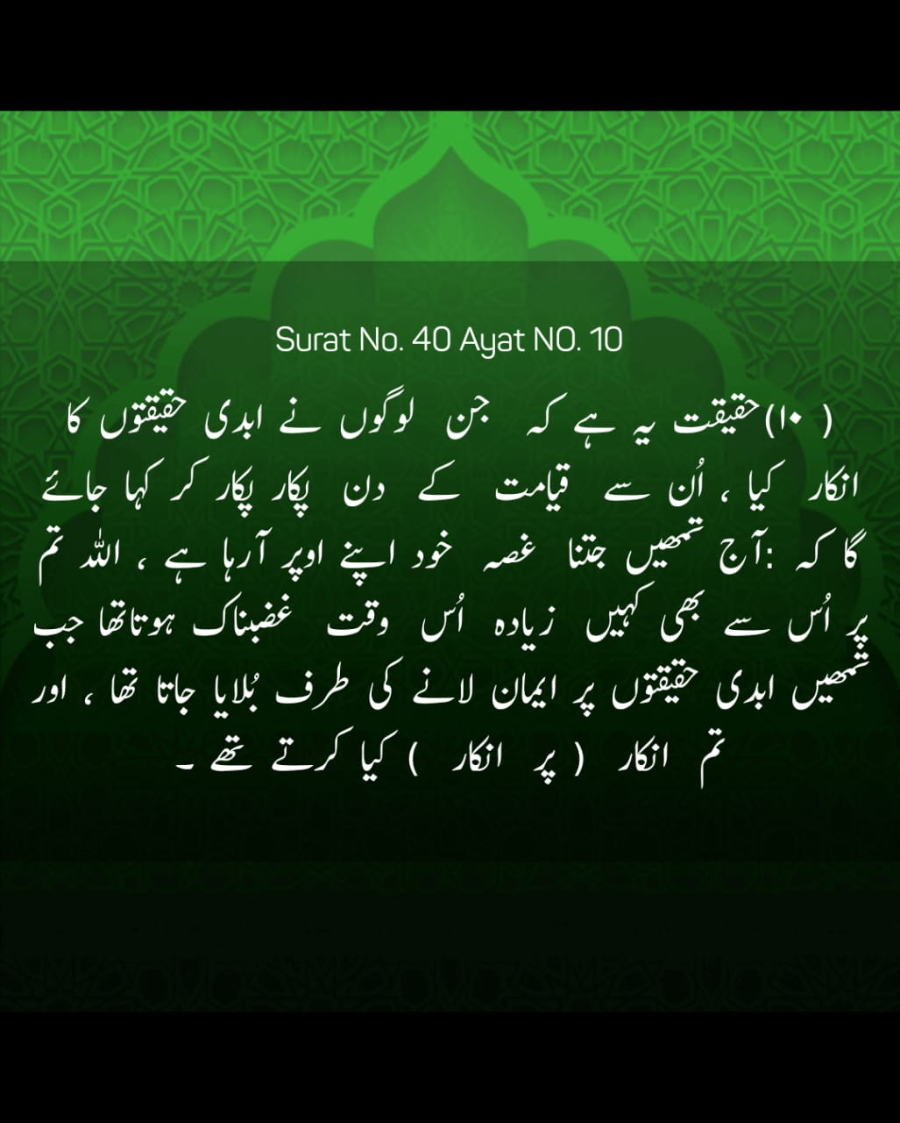

Lab Policy and Rules:

1. 100% attendance is mandatory. In case of an emergency, you can avail yourself of up to 3 absences. So, don't waste your absences , save them for emergencies. If you are debarred from the course due to low attendance, do not come to me to correct it.

2. Disturbing the class environment during lab sessions. such as by talking, using mobile phones, eating, etc. will result in penalties (e.g., deduction of marks).

3. Lab tasks will not be accepted if you are absent. If you miss a lab, you cannot submit that lab task.

4. Lab demos for each lab task will be conducted at the end of each session. If you miss the demo for any reason, no retake will be allowed, and that lab will be marked as 0.

5. All quizzes will be unannounced. Be prepared for surprise quizzes. Quizzes will cover content from previous labs as well as theory lectures from the corresponding theory course.

6. Use of AI is strictly prohibited, anyone found using AI or copying code from fellow student will be marked 0 in the lab task . You should be able to explain the syntax or material used in your tasks.

7. Do not ask for personal favors. If you have concerns, such as short attendance, please speak to the relevant authority (e.g., academics).

8. Students on warning: Now is the time to study and earn a good grade. Do not ask for extra marks at the end if you are unable to clear your warning.

Single Commands
- To clear the screen
Syntax: $ clear
- To view commands history
Syntax: $ history
- To display first 10 lines of a file
Syntax: $ head file.txt
- To display first 6 lines of a file
Syntax: $ head —n 6 file.txt
- To display first 5 lines from 2 files
Syntax: $ head —n 5 title .txt file2.txt
- To display last 10 lines of a file
Syntax: $ tail file.txt
- To display last 6 lines of a file
Syntax: $ tail —n 6 file.txt
- The wc command without passing any parameter will display a basic result Of "file_txt' file. Result Of wc command will be (number of lines), (number or words) and (number of chars/bytes) of the file.
Syntax: $ wc file.txt
- To display the number or characters in a file
Syntax: $ wc —c file.txt
- To display the number of lines
Syntax: $ wc—I file.txt
- To display the number of words
Syntax: $ wc —w file.txt
- TO display number Of lines with numbers
Syntax: $ nl file.txt
- To sort the content of file
Syntax: $ sort file.txt
- To sort the content Of file in reverse orderz
Syntax: $ sort -r file-txt
- To display the calendar.
Syntax: $ cal
- To display system date.
Syntax: $ date
- To display the login user details
- Syntax: $ whoami
- To display the contents of a file, line by line and page by page. we can use less command.
Syntax: $ less file.txt
- Note: to move up or down line by line use Arrow keys. And to move up page by page use 'b' key and for move down use Space key. To quit form the less command use ‘q' key.
- To copy the file to another file
$ cp file1 -txt file2.txt
- To copy a file within the other directory
$ cp file2.txt "Documents/directory1
- To move a file to another directory
$ rmv file1.txt directory2
$ mv —Documents/file1.txt directory3
- To rename a file:
- $ mv file1.txt file2.txt
- $ mv —Documents/file1.txt —/Doeuments/file2.txt
- To delete a file
$ rm file1.txt
- $ rm Dir1/file2.txt

find command: Find command is used to search and locate the files and directories.
Find a specific file by name in current working directory and sub Directories of current working directory.
$ find —name filename
E.g: $ find —name file1.txt
Find a specific file by name in specified path(Absolute or Relative) and all sub
Directories of specified path.
$ find path —name filename
E.g: $ find ~/ Videos —name file2.txt
Find specific directory by name in current working directory and sub Directories Of current working directory.
$ find —name directory
E.g: $ find —name D1
Find a specific directory by name in specified path(AbsoJute or Relative) and all sub Directories of specified path.
$ find path —name filename
E.g: find ../Music —name M1

Ownership and Permissions
In Linux. we use permissions to control what a user can do with a file or directory.
Types of permissions
Linux uses three types of permissions:
- Read: For a file, the read permission allows a user to view the Contents Of a file. For directories. the read permission allows the user to view the names of files and other directories stored in it.
- Write: For a file. the write permission allows a user to create. modify a file. For directories. the permission allows a user to modify Its contents (create. delete rename files in it).
However. this permission has no effect on directories unless the execute permission is also enabled.
- Execute: When set on a file. it works files that are executable like script files. C executable files etc. However. the permission has no effect on a file unless the read permission is also enabled. On the other hand. tor directories. the write permission allows the user to enter the directory.
Permission Classes
For any file or directory. there are three types of "permission classes". You can assign different permissions to these classes, and thus control who can access and modify files. The permission classes are as follows:
- User: Permissions in this class affect the owner of the file.
- Group: Permissions in this class affect the group which owns the file. However. if the owner user is in this group, the "user" permissions apply. instead of the group permissions.
- Other: Permissions in this class affect all other users on the system.

Viewing permissions
The easiest way to view the permissions of files in a given directory is to run:
ls -l

After the execution of command (ls Output of command shows, the "file mode" column which displays the file type and permissions in a compact way, as shown below:
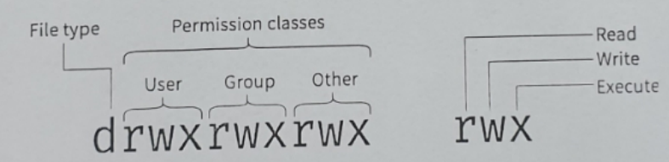

The first character represents the type of file, e.g A normal file is represented with a -, directories with a d etc. I-hen. we have the permissions often corresponding to the “user". "group" and "other" classes. The triplet rwx represents whether these classes have the read. write and execute permissions. If a - appears in this triplet. it means (hat the corresponding permission is disabled.
Using Chmod Command to Change File Permissions
As all Linux users. you will at some point need to modify the permission settings of a file/directory.
The command that executes such tasks is the chmod command.
The basic syntax is:
chmod [permission] [file_name]
There are two ways to define permission:
l. using symbols (characters)
2. using the octal notation method
Define File Permission with Symbolic Mode
To specify permission settings using alphanumerical characters. you'll need to define accessibility for the user or owner (u). group (g). and others (o).
Example Commands using Symbolic Mode:
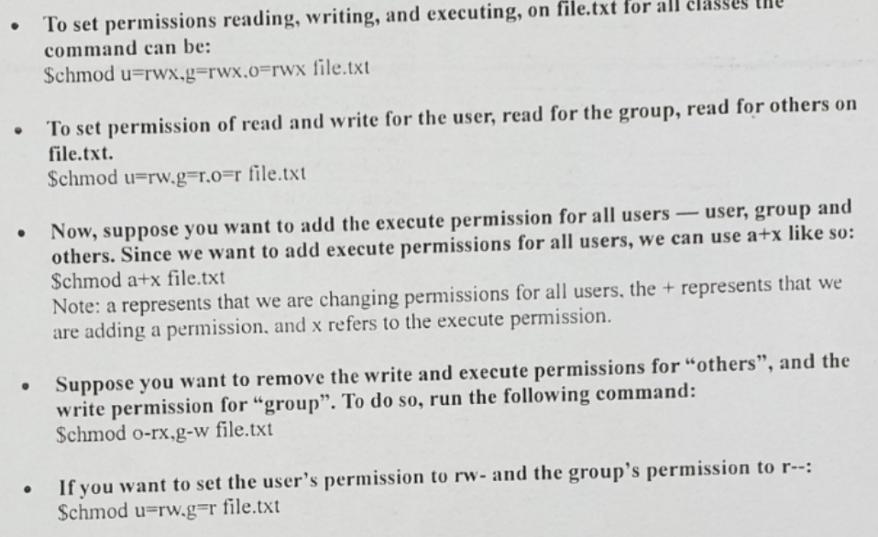

Define File Permission with octal/numeric Mode
Another way to specify permission is by using the octal/numeric format. This option is faster, as it requires less typing, although it is not as straightforward as the previous method. !nstead of letters. the octal format represents privileges with numbers:
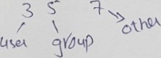
- read has the value of4
- write has the value of 2
- execute has the value of I
- no permission has the value of 0
The privileges are summed up and depicted by one number. Therefore. the possibilities are:
- 7 — for read. write. and execute permission
- 6 — for read and write privileges

chmod 774 file.txt
above command gives read, write and execute to user and groups while read only to others.

Other Shell Commands
$ whoami command
The whoami command prints the user name who currently logged-in.
$ hostname command
A hostname command is used to display the computer's hostname.
$ cal command
cal command is used to display the calendar.
$ which CommandName
command which command in Linux is a command which is used to locate the executable file associated with the given command. For example: “$which ls” will give us the output “/bin/ls”. Means it displays the path where that executable ls is stored.
$ echo SomeString command
echo is a command that outputs the string it is being passed as arguments. For example: $echo “Hello” will give us the output “Hello”
pipe command
In linux, the pipe command(represented as | symbol), sends the output of one command to another command as an input. For Example: In the following example output of ls –l command is send to less command as an input. $ ls –l | less

Tasks:

Create a file example.txt with at least 20 lines in home directory.
- Display the first 5 lines of the file.
- Display the first 10 lines of the file.
- Display the last 5 lines of the file.
- Display lines 6-10.
- Display the first 100 bytes:
- Display the last 100 bytes:
Create another file example2.txt with at least 30 lines.
- Display the first 3 lines of both files.
- Display the last 3 lines of both files.
- Search for a file named example.txt in your home directory.
- Find all .txt files in the /home/user/documents/ directory.
- Find all files larger than 100MB in the /var/log/ directory.
- Find all files smaller than 1KB in your current directory.
- Find all empty files in /var/ directory.
- Find all empty directories in your home directory.
- Change the permissions of example.txt so that only the owner has read, write, and execute permissions, while the group and others have no permissions. Using octal number.
- Change the permissions of example.txt so that everyone (owner, group, others) has read and write permissions. Using octal number
- Change the permissions of example.txt so that it is read-only for the owner, group, and others. Using octal number.
- Change the permissions of example.txt so that others (everyone except the owner and group) have no permissions at all.
- Change the permissions of example.txt so that the group and others lose their write permissions but retain any other existing permissions.
- Use symbolic notation to give the owner execute permission, the group read and execute permissions, and others only execute permission.
- Change the permissions of example.txt so that everyone (owner, group, others) can execute the file, without affecting other permissions. Without using u, g and o.

Task Submission Guidelines:
- Make a document and paste all tasks solution there (Not screenshot) and save it as pdf.
- Along with each task solution, also upload the screenshot of the output.
- Include your name and roll no. at the front page.
- Please submit your file in this format (Roll_number-name) i.e (24I-1234-Ali.pdf).
- Files other than pdf will not be accepted and will be marked as 0.

